Fibroid embolization patient leaflet

What are fibroids?

Uterine fibroids are non-cancerous growth of the uterus, of different sizes ranging from very small causing no symptoms to bulky masses that can distort the womb and cause heavy menstrual bleeding, pressure on bladder can present either as frequency in passing urine (water) or difficulty to empty the bladder. While pressure on the back and back passage can cause back pain or legs pain and constipation respectively.
It is not clear why fibroids develop in a minority of women not others, as they are more common in women with darker skin. However, we know that they are made up of muscle, are very vascular and are influenced by sexual hormones, especially oestrogen and they most likely shrink after the menopause.
A family history of fibroids and obesity increase the risk of developing uterine fibroids. However, having a healthy diet and increasing physical activity help keeping weight within healthy limits.
The types of fibroid depend on its location and many patients can have a mixture of those types at the same time. The different locations include: a) under the surface of the womb (sub-serosal), within the wall of the uterus (intra-mural), under the lining of the womb(sub-mucosal) or within the cavity of the womb.

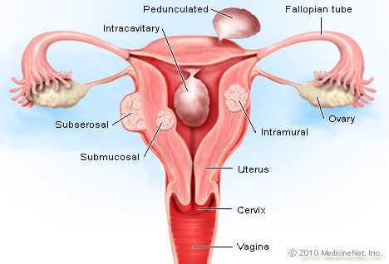

Figure 1: localisation of uterine fibroids (Adapted from MedicineNet for medical education of patient)
Knowing the location of the fibroid is important for women who desire to become pregnant. Since fibroids can grow during pregnancy under the influence of sexual hormones and cause discomfort, infertility and miscarriage.

How fibroids are diagnosed?
Women who present with symptomatic fibroids will be referred for further investigations. Ultrasound scan is the first approach to confirm the presence of fibroid. MRI scan is an important diagnostic tool to show the number, size, blood supply and location of fibroids. It is also important to rule out any other pathology which either co-exist or misdiagnosed with fibroid. Others investigations might be required in certain cases such hysteroscopy and laparoscopy.

Treatment options for uterine fibroids:
Treatment offered are not totally risk free. For this reason, the risks of treatment should always be weighed up against potential benefits. Usually fibroids causing no problems should be left untreated.
There are many options available for treatment of problematic fibroids. Medications are the first option to help relieve the symptoms or to shrink fibroids. Surgery includes hysterectomy (removal of the womb), or myomectomy (removal of the fibroids only, leaving the uterus in place), while interventional radiological treatment refers to Magnetic Resonance Guided High Intensity Focused Ultrasound (MR Guided HIFU), MR Guided percutaneous Laser Ablation of fibroid and Uterine Artery Embolisation (UAE). Treatment proposed depends on your age, clinical symptoms, localisation, size of the fibroid and the desire to have children or preservation of the uterus.
Based on NICE (National Institute for Health and Clinical Excellence) guidance, myomectomy or uterine artery embolization (UAE) should be offered for women with heavy menstrual bleeding and fibroids who want to retain their fertility.

Uterine Artery Embolisation (UAE):
UAE is a minimally invasive procedure which is carried out by the interventional radiologist in operating theatre using local or general anaesthesia. It takes about thirty to sixty minutes to perform, and generally accepted by many patients. Women planning to get pregnant or very keen to get pregnant, should have thorough discussion with the interventional radiologist prior to UAE. Not all patients with uterine fibroids are entitled to have the UAE. Ongoing pregnancy, active pelvic infection or cancer, allergic reaction to contrast material, and dead fibroids are examples of patients who should not be offered UAE.

How the UAE works?
It works by injecting tiny particles into the uterine arteries via a small plastic tube (about 1.5mms wide threaded catheter) inserted through a pinhole incision into the main artery in the groin (femoral artery) or left wrist (radial artery). The catheter is then guided into position within uterine artery using imaging guidance (Figure 1).

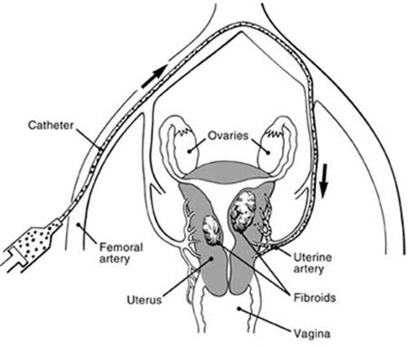

Figure 1 curtesy of the BSIR website UAE scheme (Courtesy of the BSIR)

Once in position, the tiny particles (300-700 microns) are injected to block the blood supply to the fibroids. This is verified by fluoroscopic image guidance taken during the procedure. The particles are safe substance made of alcohol or gelatine based chemicals and licensed for use in human body for so many years with no known side effect. At the end of the procedure , the catheter is removed and local pressure is applied to prevent bleeding. The patient needs to stay overnight in hospital for one or two days to control and make sure the woman is making steady recovery. Patients are generally advised to stay off work for almost 7-10 days.

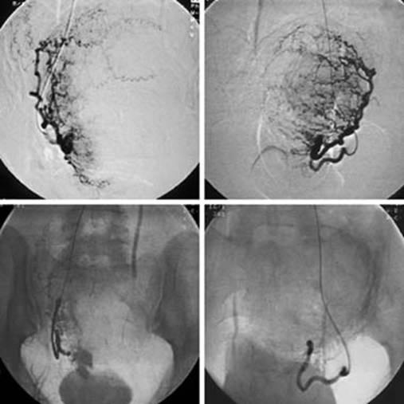

Figure 2: X-rays before and after the UAE (Adapted from BSIR for medical education of patient)

Risks of UAE
Although UAE is very minimally invasive procedure, named complications might happen. These rare complications are more or less similar to any other surgical treatment for fibroids. The procedure is painless apart from the first needle of local anaesthesia. However, following the procedure, significant pain is expected. It is a sign of successful procedure and it is likely due to drop in blood supply to fibroids and uterine tissue. There is robust protocol of pain control and this will be discussed with the patient in details by the interventional radiologist and the anaesthetist. Post embolization syndrome (PES) is another common issue experienced in the first few days after UAE. The syndrome is characterised by low grade temperature, pain, fatigue, nausea and vomiting that usually resolve within one week.
Ongoing symptoms beyond this period warrant further evaluation for the possibility of the development of an infection in 1-2% of cases. Infection is usually controlled with antibiotics prescribed by the GP. In very rare cases, infection could be severe with high fever, severe abdominal pain and smelly vaginal discharge. In these rare circumstances ,the patient needs to come to the A&E for hospital admission and intravenous antibiotics. The majority of cases with infection respond to medical treatment and only in very rare cases would be considered for hysterectomy.
Disturbance of the ovarian blood supply is a possibility because the ovaries receive, at least in part, blood from the same arteries supplying the uterus. Women in their forties or near to menopause age can be affected by this disruption. The risk of menopause following UAE is very rare but increases with age.

Follow up
A repeat of MRI is usually scheduled 6 months after the procedure to assess the response to intervention and give insight about the chances of recurrence.

Results of the UAE

The majority of patients undergoing UAE report symptoms relief such as reduction in heavy bleeding, length of period, abdominal enlargement and urinary (water works) problems. are observed in the first three months after the uterine embolization. The success rate of UAE is high, but in small cases there is risk of recurrence of the fibroids. In small number of patient, women might enter the menopause, especially among women over the age of 45 years. Regarding fertility, there have been cases of successful pregnancies, prematurity, miscarriages and postpartum bleeding. Unfortunately, data on pregnancy rate after UAE in the general population is scarce. The published data showed definite benefits of UAE in patient with multiple fibroids and even large size fibroids.

Patient counselling
Patient counselling is the best opportunity for the doctor and patient alike to discuss the pro and cons of every procedure tailored to the patient’s condition. Open discussion about all benefits and potential risks of the procedure should take place.
You will receive a letter explaining how you prepare for the procedure, what to expect during the procedure and how you will be monitored after the procedure.

More information
For further information on uterine fibroids, please follow the following links :

a-https://www.bsir.org/patients/fibroids/#col_right
b-http://www.britishfibroidtrust.org.uk
c-https://cks.nice.org.uk/topics/fibroids/management/management/
d-https://www.nhs.uk/conditions/fibroids/
e- https://www.guysandstthomas.nhs.uk/resources/patient-information/gynaecology/Fibroids.pdf

